

Project Interim Report

On

File Compression Simulator (Using Core Java & OOP Concepts)
RU-100-01-00012
Object Oriented Programming with Java

SESSION: 2025-26

Submitted By
Student name – vidya kumari
Reg No. - RU-25-11594

Bachelor of Technology in Computer Science & Engineering with AI and ML in association with Google

Under the Guidance of Mr. Harsh Multani

SCHOOL OF COMPUTER SCIENCE AND ENGINEERING RUNGTA INTERNATIONAL SKILLS UNIVERSITY
BHILAI, CG

(April 2026)

Abstract
The Hotel Room Reservation Application is an Object-Oriented Programming (OOP) based project that simulates a hotel booking system. It is designed to manage room reservations efficiently using concepts like classes, objects, interfaces, and arrays.
This project is needed to avoid manual errors in booking and to maintain proper records of room availability. It helps hotels handle reservations in a more organized and reliable way.
The system stores room details such as room number, type, price, and availability. It allows users to book and cancel rooms while updating their status. It also calculates the total bill based on the number of days stayed and room rate.

Introduction
The Hotel Room Reservation Application is an OOP-based project that simulates a hotel booking system. It is designed to manage room records, handle reservations, and calculate billing in an efficient and structured way using concepts like classes, objects, interfaces, and arrays.
This project is needed to reduce manual work, avoid booking errors, and maintain accurate records of room availability. It helps improve efficiency and reliability in hotel management.
The system manages room details such as room number, type, price, and availability. It allows users to book and cancel rooms while updating their status. It also calculates the total bill based on the number of days stayed.

Objectives
- Manage room records
- Track booked and available rooms
- Reduce manual work
- Implement booking and billing system
- Apply OOP concepts

Scope
This project is suitable for small hotels and can be extended with database integration in the future.

System Requirements
Hardware: Computer with 4GB RAM
Software: Java JDK, IDE (VS Code/Eclipse/Edit Plus)

Methodology
The project works in a step-by-step process to manage hotel room reservations efficiently.
- Initialize Data
First, all rooms are created and stored in a 2D array with details like room number, type, price, and availability.
- View/Search Rooms
The user can view or search for available and booked rooms.
- Book Room (Add Record)
The user selects a room. If it is available, the system books it and updates its status.
- Modify (Cancel Booking)
If needed, the user can cancel the booking, and the room becomes available again.
- Calculate Bill
The system calculates the total cost based on the number of days stayed and room rate.
- Display Updated Data
Finally, the system shows updated room details and availability

Flowchart

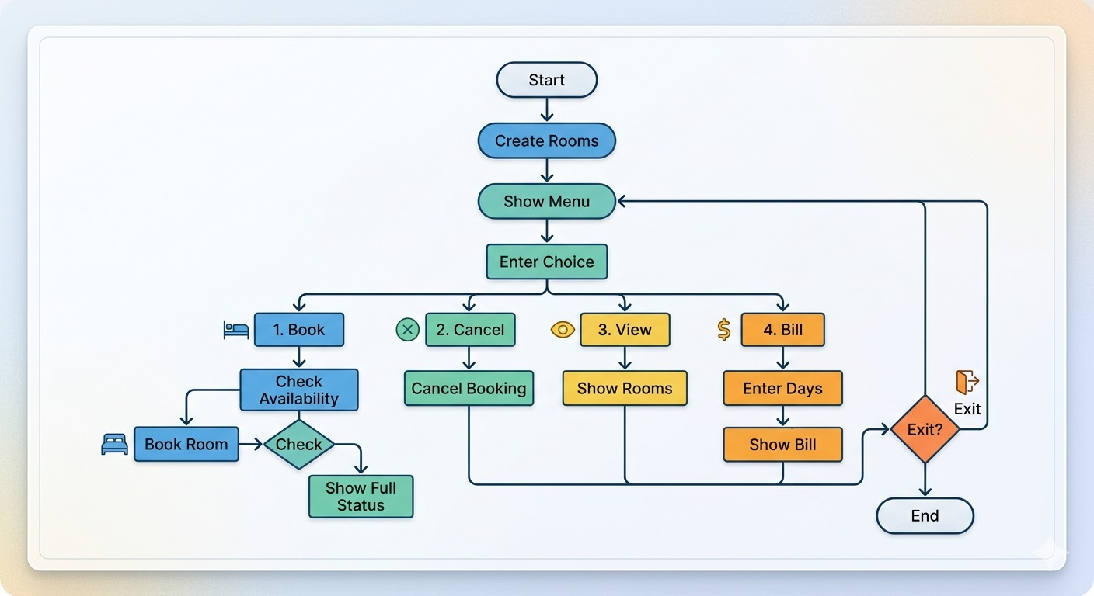

ClassName

Room Class
- Variables inside class:
roomNumber, roomType, pricePerDay, isAvailable
- Methods inside class:
Constructor to initialize values, getter/setter methods (optional)
- Array:
No array used in this class

Hotel Class
- Variables inside class:
rooms (to store all room objects)
- Methods inside class:
bookRoom(), cancelBooking(), displayRooms()
- Array:
2D array used → Room[][] rooms (to manage rooms floor-wise)

Service Interface
- Variables inside interface:
No variables
- Methods inside interface:
calculateBill(days, rate)
- Array:
No array used

Implementation
- Room Class:
This class is used to store details of each room like room number, type, price, and availability. It helps in managing the status of individual rooms.
- Hotel Class:
This is the main class that controls the system. It stores all rooms in a 2D array and performs operations like booking a room, canceling a booking, and displaying room status.
- Service Interface:
This is used for billing. It calculates the total cost based on number of days and room rate, showing the use of abstraction.

Implementation
Classes Used (Logic):
- Room Class: Stores room details like number, type, price, and availability.
- Hotel Class: Manages all rooms using a 2D array and handles booking, cancellation, and display.
- Service Interface: Used to calculate the total bill based on days and room rate.

Sample Input/Output
Input:
Floor: 1, Room: 2, Days: 3
Output:
Room booked successfully
Total Bill: 4500.0

Screenshot
👉 Paste your terminal output showing booking, cancel, and billing.

Future Enhancements
- Add database support
- Create GUI
- Store customer details
- Add advanced billing features

Gantt Chart

A Gantt chart is used to plan and manage the project by dividing it into tasks and assigning time for each task.

1. Planning & Structure
The project is divided into different phases such as:
- Requirement analysis
- System design
- Coding
- Testing
- Final implementation
This helps in organizing the work step-by-step and ensures a clear structure for project development.

2. Time Management
The Gantt chart shows:
- When each task starts
- When each task finishes
This helps in:
- Completing work on time
- Avoiding delays
- Reducing last-minute pressure

Conclusion
The project successfully demonstrates Java OOP concepts and provides a functional system for managing hotel room reservations. It effectively handles room booking, cancellation, and billing operations while reducing manual work. The project also shows how real-world problems can be solved using a structured and modular programming approach.

References

Book
Format:
[1] Author(s), Book Title, Edition. City: Publisher, Year.
Example:
[1] H. Schildt, Java: The Complete Reference, 11th ed. New York: McGraw-Hill, 2018.

Website Format
Format:
[2] Author (if any), "Title of page," Website Name. [Online]. Available: URL
Example:
[2] Oracle, "Java Documentation," Oracle. [Online]. Available: https://docs.oracle.com

Conference Paper
Format:
[3] Author(s), "Paper title," in Proc. Conference Name, year, pp.
Example:
[3] S. Kumar, "Software Design in Real World Applications," in Proc. IEEE Conf. on Software Engineering, 2021, pp. 120-125.

Journal Article
Format:
[4] Author(s), "Title of paper," Journal Name, vol., no., pp., year.
Example:
[4] A. Sharma and R. Gupta, "Object Oriented Programming Concepts," International Journal of Computer Science, vol. 5, no. 2, pp. 45-50, 2020.

